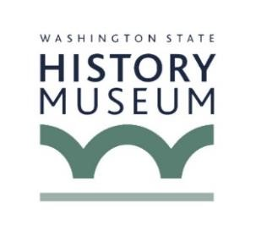
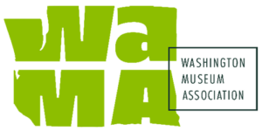
NEWS RELEASE
FOR IMMEDIATE RELEASE: XXX
MEDIA CONTACT: Name, Title
Phone
Email

The Washington State Historical Society & Washington Museum Association Host State-Wide Museum Day

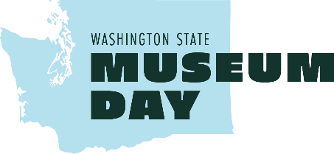
[City], WA – More than 100 museums across Washington State will open their doors at free or reduced rates to visitors on Museum Day, Saturday, August 8, 2026.
Museum Day is part of the State-wide commemoration of the semiquincentennial, America's 250th anniversary of the signing of the Declaration of Independence. Communities across Washington are preparing local events to commemorate this unforgettable year, including Museum Day, intended to promote and share local history.
For a full list of participating museums, hours of operation, and admissions, visit https://washingtonmuseumassociation.org/museum-day/participating-museums.
Preserving and sharing local history for all is one of three key themes in the State’s 250th initiative.
“Learning about our history, sharing our stories, and preserving our history for future generations is a key component of our approach to the semiquincentennial. Here in Washington, we are doing that by connecting with local communities, local histories, and local voices,” says Lieutenant Governor Denny Heck.
As the Washington Semiquincentennial Committee chair, Lt. Governor Heck encourages every Washingtonian to engage in commemorative activities this year. Museum day offers a low-barrier, often free, way to dig into history, arts, and cultural experiences across the state!
###

About The Washington State Historical Society and History Museum
The Washington State Historical Society works with our communities to explore how history connects us all. Its most prominent activity is the Washington State History Museum, located in Tacoma's Museum District on Pacific Avenue. The museum features interactive core exhibitions about Washington in the Great Hall, rotating special exhibitions, and various public events and programs that cover a wide range of historical topics. The WSHS provides curriculum resources, downloadable exhibitions, and educational support across the state, as well as consultation and resources for museums and heritage organizations.

About the Washington Museum Association
The Washington Museum Association (WaMA) has supported Washington’s museum community since 1980, connecting museums of all types and sizes through advocacy, professional development, and networking. WaMA strengthens the capacity of museums across the state, and champions the vital role museums play within their communities.
https://washingtonmuseumassociation.org/

