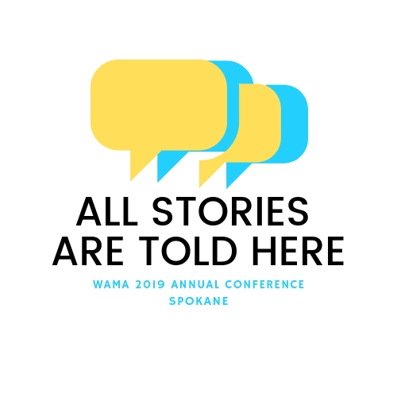
Call for Proposals
2019 Washington Museum Association Conference
All Stories are Told Here

The Washington Museum Association (WaMA) offers an annual conference for peer-to-peer learning, networking, and idea exchange. The 2019 WaMA Conference takes place at the Northwest Museum of Arts & Culture in Spokane, WA, June 19 – 21, 2019. WaMA is currently inviting proposals for presentations, workshops/interactive sessions, or panels. We also welcome student poster sessions, during which students may share projects or research of interest to museum professionals.

Do you have an initiative you would like to share or an issue you’d like to explore with colleagues? Topics for sessions may include: community engagement, collaboration, exhibit development, strategic planning, collections stewardship, facilities and safety, technology, cultural tourism, interpretation, museum management and leadership, and/or fundraising.
To propose a session, complete the information below and send or email to:

Elizabeth P. Stewart, WaMA Vice President / estewart@rentonwa.gov

Proposals may also be submitted through our website:
www.washingtonmuseumsassociation.org

Name:____________________________________________________
Museum/Affiliation:_________________________________________
Street Address:_____________________________________________
City: ________________________ State: ________Zip: ____________
Telephone: ________________________________
Email: ____________________________________
Note: WaMA conference policy does not allow for reimbursement of expenses. All session participants must register for the conference.

Please include all of the following:
- Session title (10 words or less)
- Type (please choose one): Lecture, Panel, Workshop, or Roundtable Discussion
- Description (about 70 words)
- Session Moderator / Coordinator’s Name (main contact)
- Names of presenters and their institutional affiliation
- Audiovisual needs

DEADLINE: December 1, 2018

